**Objectives • Explain git ignore • Explain how to ignore unwanted files using git ignore In this hands-on lab, you will learn how to: • Implement git ignore command to ignore unwanted files and folders Prerequisites The following are the pre-requisites to complete this hands-on lab: • Setting up Git environment • Integrate notepad++ as a default editor • A Git repository in the local system and a remote repository in GitLab Notes*: Please follow the below steps for creating a free account in GitHub. Do not use cognizant credentials to login to GitHub. Estimated time to complete this lab: 20 minutes. Create a “.log” file and a log folder in the working directory of Git. Update the .gitignore file in such a way that on committing, these files (.log extensions and log folders) are ignored. Verify if the git status reflects the same about working directory, local repository and git repository.**

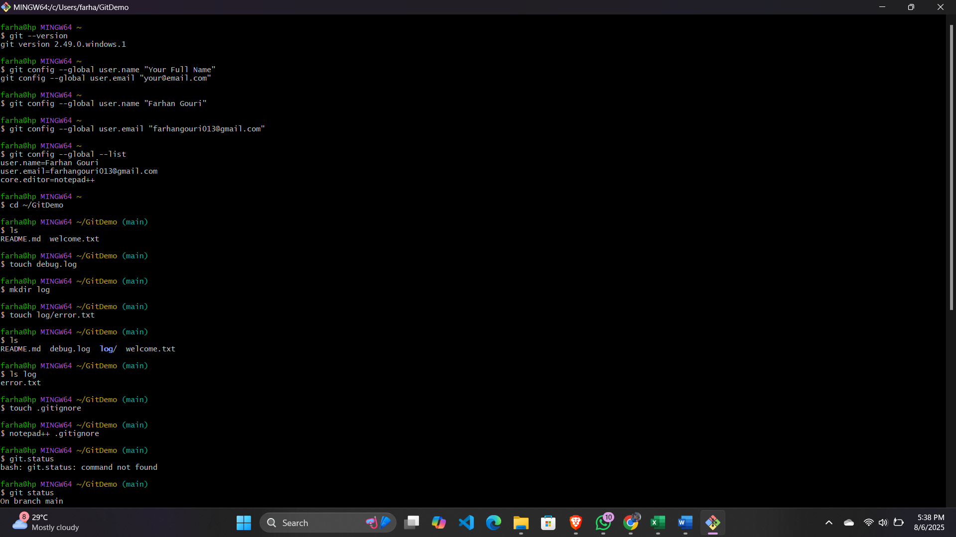**Code:**

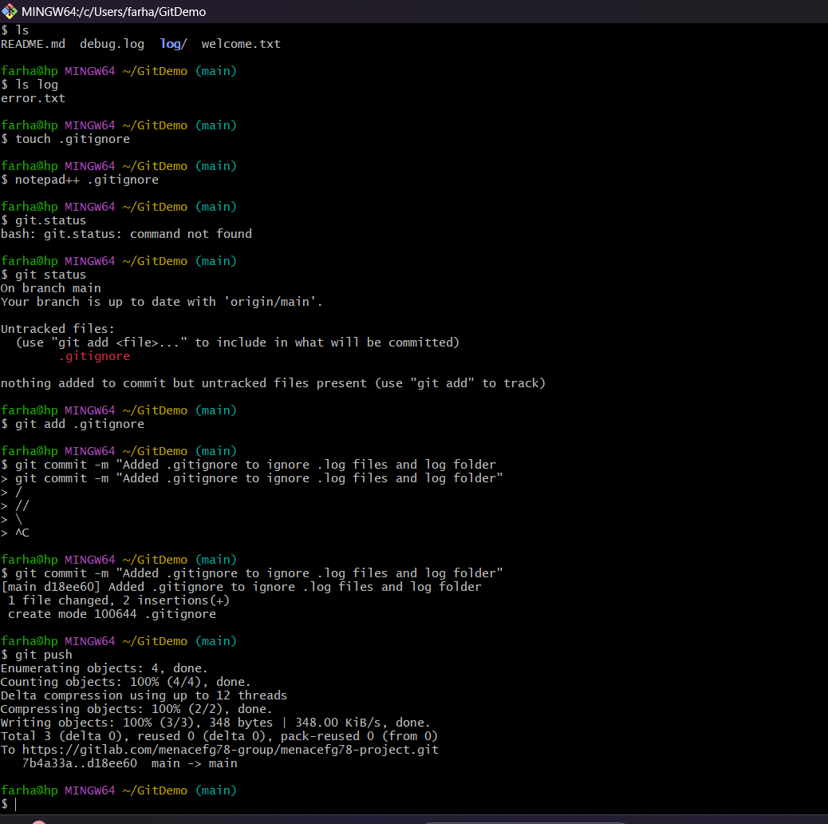**d**

**Code as text:**

farha@hp MINGW64 ~

$ git --version

git version 2.49.0.windows.1

farha@hp MINGW64 ~

$ git config --global user.name "Your Full Name"

git config --global user.email "your@email.com"

farha@hp MINGW64 ~

$ git config --global user.name "Farhan Gouri"

farha@hp MINGW64 ~

$ git config --global user.email "farhangouri013@gmail.com"

farha@hp MINGW64 ~

$ git config --global --list

user.name=Farhan Gouri

user.email=farhangouri013@gmail.com

core.editor=notepad++

farha@hp MINGW64 ~

$ cd ~/GitDemo

farha@hp MINGW64 ~/GitDemo (main)

$ ls

README.md welcome.txt

farha@hp MINGW64 ~/GitDemo (main)

$ touch debug.log

farha@hp MINGW64 ~/GitDemo (main)

$ mkdir log

farha@hp MINGW64 ~/GitDemo (main)

$ touch log/error.txt

farha@hp MINGW64 ~/GitDemo (main)

$ ls

README.md debug.log **log**/ welcome.txt

farha@hp MINGW64 ~/GitDemo (main)

$ ls log

error.txt

farha@hp MINGW64 ~/GitDemo (main)

$ touch .gitignore

farha@hp MINGW64 ~/GitDemo (main)

$ notepad++ .gitignore

farha@hp MINGW64 ~/GitDemo (main)

$ git.status

bash: git.status: command not found

farha@hp MINGW64 ~/GitDemo (main)

$ git status

On branch main

Your branch is up to date with 'origin/main'.

Untracked files:

(use "git add <file>..." to include in what will be committed)

.gitignore

nothing added to commit but untracked files present (use "git add" to track)

farha@hp MINGW64 ~/GitDemo (main)

$ git add .gitignore

farha@hp MINGW64 ~/GitDemo (main)

$ git commit -m "Added .gitignore to ignore .log files and log folder

> git commit -m "Added .gitignore to ignore .log files and log folder"

> /

> //

> \

> ^C

farha@hp MINGW64 ~/GitDemo (main)

$ git commit -m "Added .gitignore to ignore .log files and log folder"

[main d18ee60] Added .gitignore to ignore .log files and log folder

1 file changed, 2 insertions(+)

create mode 100644 .gitignore

farha@hp MINGW64 ~/GitDemo (main)

$ git push

Enumerating objects: 4, done.

Counting objects: 100% (4/4), done.

Delta compression using up to 12 threads

Compressing objects: 100% (2/2), done.

Writing objects: 100% (3/3), 348 bytes | 348.00 KiB/s, done.

Total 3 (delta 0), reused 0 (delta 0), pack-reused 0 (from 0)

To https://gitlab.com/menacefg78-group/menacefg78-project.git

7b4a33a..d18ee60 main -> main

farha@hp MINGW64 ~/GitDemo (main)

**Output:**

